Course Name: | Competitive Programming Laboratory (216U01L401) | Semester: | IV
Date of Performance: | 04/04/2025 | DIV/ Batch No: | C3
Student Name: | Om Satish Thanage | Roll No: | 16010123217

Experiment No: 7
Title: To use a Game theory approach to solve competitive programming problems.
You are playing the following Nim Game with your friend:
Initially, there is a heap of stones on the table.
You and your friend will alternate taking turns, and you go first.
On each turn, the person whose turn it is will remove 1 to 3 stones from the heap.
The one who removes the last stone is the winner.
Given n, the number of stones in the heap, return true if you can win the game assuming both you and your friend play optimally, otherwise return false.

Example 1:
Input: n = 4
Output: false
Explanation: These are the possible outcomes:
1. You remove 1 stone. Your friend removes 3 stones, including the last stone. Your friend wins.
2. You remove 2 stones. Your friend removes 2 stones, including the last stone. Your friend wins.
3. You remove 3 stones. Your friend removes the last stone. Your friend wins.
In all outcomes, your friend wins.

Example 2:
Input: n = 1
Output: true

Example 3:
Input: n = 2
Output: true

Aim and Objective of the Experiment:
- Understand the concepts of geometry-based approach.
- Apply the concepts to solve the problem.
- Implement the solution to given problem statement.
- Create test cases for testing the solution.
- Analyze the result for efficiency of the solution.

COs to be achieved:
CO4: Apply geometry, game theory, and string algorithms in competitive programming.

Books/ Journals/ Websites referred:
- https://leetcode.com/problems/nim-game/description/
- https://usaco.guide/CPH.pdf

Theory:
- Nim Game is played with multiple heaps (or piles) of objects (like stones or sticks).
- Players take turns, and in one move, a player removes any number of objects from a single heap.
- The player who removes the last object wins (standard version).
- The game's key concept is the Nim Sum: the XOR of all heap sizes.
- Nim Sum = heap1 ^ heap2 ^ heap3 ^ ... ^ heapN
- If the Nim Sum is 0, the current player is in a losing position if the opponent plays perfectly.
- If the Nim Sum is not 0, the current player is in a winning position with the right moves.
- The player can win by making a move that changes the state to make the Nim Sum 0.
- This is based on the Sprague-Grundy theorem from combinatorial game theory.
- Your code correctly predicts the winner by checking the Nim Sum and who plays first.
- This prediction assumes that both players play optimally.

Problem statement
- The states in nim are of the form [x1, x2,..., xn], where xk denotes the number of sticks/coins/objects in heap k.
- For example, [10,12,5] is a game where there are three heaps with 10, 12 and 5 sticks.
- The state [0,0,...,0] is a losing state, because it is not possible to remove any sticks, and this is always the final state.
The Winning Strategy:
- It turns out that we can easily classify any nim state by calculating the nim sum s = x1 ⊕ x2 ⊕··· ⊕ xn, where ⊕ is the xor operation.
- The states whose nim sum is 0 are losing states, and all other states are winning states.
- For example, the nim sum of [10,12,5] is 10⊕12⊕5 = 3, so the state is a winning state
Now, if the Nim-Sum is 0 at the start of your turn, you’re in trouble. But if it’s non-zero, you can force a win!
Here’s how:
- If the Nim-Sum is non-zero, you can make a move that results in a Nim-Sum of zero for your opponent.
- To do this, find a pile where the XOR of that pile with the Nim-Sum is less than the current size of that pile.
- Remove the appropriate number of objects to achieve this.
- As an example, consider the state [10,12,5]. This state is a winning state, because its nim sum is 3. Thus, there has to be a move which leads to a losing state. Next we will find out such a move.
- The nim sum of the state is as follows:
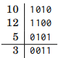
- In this case, the heap with 10 sticks is the only heap that has a one bit at the position of the leftmost one bit of the nim sum:
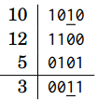
- The new size of the heap has to be 10⊕3 = 9, so we will remove just one stick.After this, the state will be [9,12,5], which is a losing state:
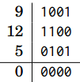
Who wins?
Fact 1: Suppose it's your turn and the Nim sum of the number of coins in the heaps is equal to 0. Then whatever you do, the Nim sum of the number of coins after your move will not be equal to 0.
- Fact 2: Suppose it's your turn and the Nim sum of the number of coins in the heap is not equal to 0. Then there is a move which ensures that the Nim sum of the number of coins in the heaps after your move is equal to 0.
- Now suppose you are player A, so you go first. Also suppose that the Nim sum of the number of coins in the heaps is not equal to 0.
- Your strategy will be this:
- if possible always make a move that reduces the next Nim sum, the Nim sum after your move, to 0.
- This would then mean that whatever player B does next, by fact 1 the move would turn the next Nim sum into a number that's not 0.
- This ping-pong between zero and non-zero Nim sums means that you are guaranteed a win!
- If player B were to win, she would have to make a move that leaves over no coins at all.
- That is; she would have to make a move that results in a zero Nim sum which, as we can see, is impossible.
- Your moves, on the other hand, always reduce the Nim sum to zero. And at some point in the game, the zero Nim sum will correspond to there actually being zero coins left — you've won.
- This shows that if the Nim sum of coins in the heaps at the start of the game is not 0, then player A has a winning strategy. The strategy is to always make a move that reduces the next Nim sum to 0.
- If the Nim sum of coins in the heaps at the start of the game is equal to 0, then player B has a winning strategy. Whatever player A does on the first move will result in a non-zero Nim sum when it's B's turn. And by the same reasoning as above, this means that the winning strategy is now in B's hands.

Code :
#include <bits/stdc++.h>
using namespace std;

int main()
{
int n;
cout << "Enter the number of piles: ";
cin >> n;

vector<int>v(n);

int xorr = 0;
cout << "Enter stones for each piles: ";
for(int i=0;i<n;i++)
{
cin >> v[i];
xorr ^= v[i];
}
int ch;
cout << "Enter who plays first: 1. player, 2. Computer: ";
cin >> ch;
switch(ch)
{
case 1:
if(xorr == 0)cout << "Computer wins" << endl;
else cout << "Player wins" << endl;
break;

case 2:
if(xorr == 0)cout << "Player wins" << endl;
else cout << "Computer wins" << endl;
break;

}

}

Output:
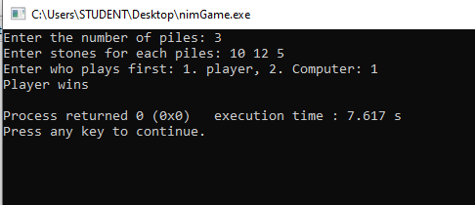

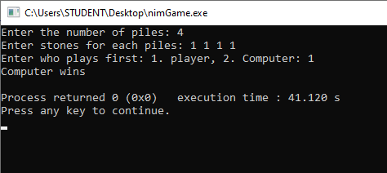

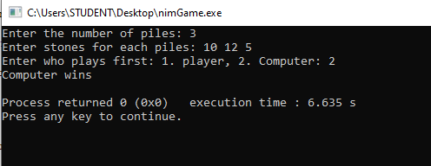

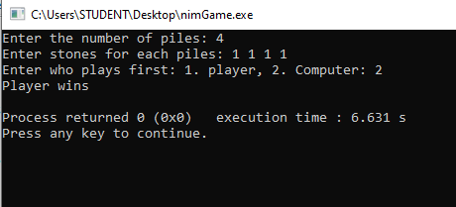

Conclusion:
We implemented nim game assuming player and computer play optimally

